Giant Squid

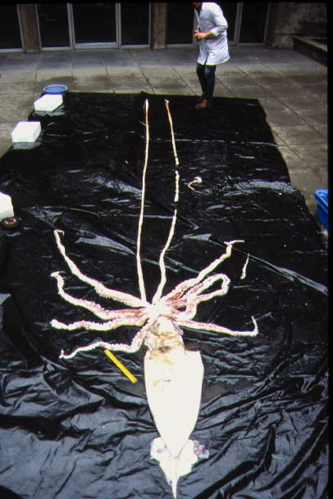
(mMm Delicious)

By Brian Cullinan
Per 4 Biology
05/11/04
The Giant Squid:
Over the years the giant squid has been portrayed as a killing monster responsible for numerous human deaths as well as sinking ships. Interestingly enough, that is not entirely untrue. Speaking of a sea monster, with long arms, that attack ships and huge whales would appeal to an adolescent, when in fact it has also appealed to many scientists. This enormous animal responsible for deaths of humans, ships, and other huge sea creatures have puzzled scientists over the years. There is evidence of squids growing to sizes of 100 feet and possibly larger. The largest recorded squid however is unknown. Some sources claim 50 feet, some claim 75 feet, but there are also those that claim the largest squid ever recorded is nearly 175 feet. (UnMuseum, 3)
Interesting Facts:
The giant squid is a marine invertebrate. A squid’s normal diet consists of shrimp, krill, macro-zooplankton, and of course the occasional bow of a ship. Its predators are the seal, toothed whale, penguin, very large birds like the albatross, and some sharks. (Tonmo, 5)
The giant squid undoubtedly looks and acts the part of a sea monster. For example the eyes of a squid are the largest in the animal kingdom and can grow to be the size of a basketball or 18 inches across. There are 200 to 300, 4 inch, suckers in two rows on each arm. These suckers are incredibly powerful and leave marks on all of its enemies. Each sucker has a ring of teeth that can hook on to any prey but most importantly can be used as a defense. The tentacles, which are used for capturing prey and drawing it towards the mouth, also have hundreds of dangerous suckers (Occultopedia, 4). The squid can move through the water up to 20 miles per hour by propelling water through a jet like organ called a siphon (UnMuseum, 3).
Reproduction:
Despite its intimidating appearances the squid lives a relatively short life, usually only 2 to 3 years. After one year of growth it has the ability to mate and reproduce. A female could lay thousands of eggs at a time. Scientists do not know where squids mate, or if they travel in groups. And even less is known about their parenting. Because it is relatives to the octopus, which does make more public appearances, it is believed that the squid as well as the octopus stay with their eggs and do not eat at all during this time. Soon after the eggs hatch, the female dies. (Tonmo, 5)
Habitat:
The giant squid enjoys the cold depths of the ocean. This makes the giant squid an incredibly hard subject to study. Scientists believe it is hard for squid to live in warm water because it affects their buoyancy and makes it difficult for them to stay under water. Therefore, the squid rarely comes any where near the top of the water. Most the time when a squid sighting is recorded it is of a dead squid. (Tonmo, 5)
Squid Attacks:
Squid have been known to attack whales even though the giant sperm whale is a predator. There is visual evidence that giant squid are aggressive towards the sperm whale. One article discusses a story from October of 1966 where two lighthouse keepers witnessed a giant squid attack a baby sperm whale. In 1965 a whaler witnessed a squid attacking an adult sperm whale. Neither subject won the battle. When the whale was found dead on the shore afterwards the squid’s head was found in the whale’s stomach and an arm was still attached around its head. The whale was believed to have been suffocated from the squid’s arm. Whales are not the only thing the giant squid attacks outside of its normal diet. (UnMuseum, 3)
Squid have also been known the attack ships deliberately. In the 1930 the Brunswick was attack by a giant squid. After pacing itself with the Norwegian navy tanker it wrapped its tentacles around the hull of the ship blocking the rudder. Unfortunately before they could examine, capture, or even measure this squid, its grip slipped and it fell into the propeller. (UnMuseum, 3)
More recently, January of 2003, BBC news reports an incident with a giant squid “attacking” the owner’s boat several hours into the voyage. The squid attached itself to the hull and blocked the rudder. When the captain Olivier De Kersauson stopped the boat, the squid released itself. Unlike in 20,000 leagues under the sea, the captain did not have to fight the squid off. It was measured 22 to 26 feet. (BBC News, 2)
Conclusion:
Not much more is known about the giant squid because of its habitat needs. It must be incredibly hard to keep in captivity because of its need for dark, cold, and extremely deep water. When a squid is found in a range that it can be studied, it is usually dead, and most of the time torn up and only comes in pieces. Therefore, for most marine biologists this animal remains almost a complete mystery and there is much more to discover.
Resources:
1. “Largest Giant Squid,” PageWise. 2002. http://nm.essortment.com/squidgiantlarg_rehq.htm
2. “Giant Squid ‘Attacks French Boat’,” BBC News. Jan. 15, 2003. http://news.bbc.co.uk/1/hi/sci/tech/2661691.stm
3. Lee Krystek, “The Giant Squid,” Lee Krystek. 2003. http://unmuseum.mus.pa.us/squid.htm
4. Marcus V. Gay, “Giant Squid,” Occultopedia. http://www.occultopedia.com/g/giant_squid.htm
5. Dr. Steve O'Shea, “Giant Squid and Colossal Squid Fact Sheet,” Tonmo. 2003-2004. http://www.tonmo.com/science/public/giantsquidfacts.php
Pictures:
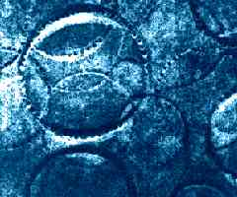
Sucker marks left on a sperm whale after a fight
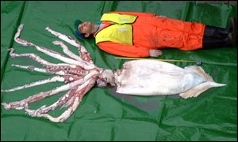
Squid that attack the French boat (22 to 26 feet)
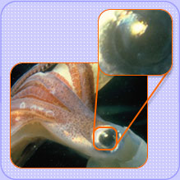
Squid eye
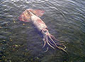
Dinner!

